Madhurya Mozumder

RA1911028010036

CSE-CC I2

**EXPERIMENT-3**

**Conversion of NFA to DFA**

**Aim:**

Write a program in your preferred language to convert a Non-deterministic Finite Automata to Deterministic Finite Automata.

Input: NFA transition states Output: DFA transition table

**Algorithm:**

1. Construct the transition table of given NFA machine.
2. Scan the next states column in the transition table from initial state to final state.
3. If any of the next state consists more than one state on the single input alphabet. Then merge them and make it new state. Place this new constructed state in DFA transition table as present state.
4. The next state of this new constructed state on input alphabet will be the summation of each next state which parts in the NFA transition table.
5. Repeat step 2 to step 4 until all the states in NFA transition table will be scanned completely.
6. The finial transition table must have a single next state at a single input alphabet.

**Code:**

#include<stdio.h> #include<string.h> #include<math.h>

int ninputs;

int dfa[100][2][100] = {0};

int state[10000] = {0}; char ch[10], str[1000]; int go[10000][2] = {0};

int arr[10000] = {0}; int main()

{

int st, fin, in; int f[10];

int i,j=3,s=0,final=0,flag=0,curr1,curr2,k,l; int c;

printf("\nFollow the one based indexing\n");

printf("\nEnter the number of states::"); scanf("%d",&st);

printf("\nGive state numbers from 0 to %d",st-1); for(i=0;i<st;i++)

state[(int)(pow(2,i))] = 1;

printf("\nEnter number of final states\t"); scanf("%d",&fin);

printf("\nEnter final states::"); for(i=0;i<fin;i++)

{

scanf("%d",&f[i]);

}

int p,q,r,rel;

printf("\nEnter the number of rules according to NFA::"); scanf("%d",&rel);

printf("\n\nDefine transition rule as \"initial state input symbol final state\"\n");

for(i=0; i<rel; i++)

{

scanf("%d%d%d",&p,&q,&r); if (q==0)

dfa[p][0][r] = 1; else

dfa[p][1][r] = 1;

}

printf("\nEnter initial state::"); scanf("%d",&in);

in = pow(2,in); i=0;

printf("\nSolving according to DFA");

int x=0; for(i=0;i<st;i++)

{

for(j=0;j<2;j++)

{

int stf=0; for(k=0;k<st;k++)

{

if(dfa[i][j][k]==1)

stf = stf + pow(2,k);

}

go[(int)(pow(2,i))][j] = stf;

printf("%d-%d-->%d\n",(int)(pow(2,i)),j,stf); if(state[stf]==0)

arr[x++] = stf; state[stf] = 1;

}

}

//for new states for(i=0;i<x;i++)

{

printf("for %d ",arr[x]);

for(j=0;j<2;j++)

{

int new=0; for(k=0;k<st;k++)

{

if(arr[i] & (1<<k))

{

int h = pow(2,k);

if(new==0)

new = go[h][j];

new = new | (go[h][j]);

}

}

if(state[new]==0)

{

arr[x++] = new; state[new] = 1;

}

}

}

printf("\nThe total number of distinct states are::\n"); printf("STATE 0 1\n");

for(i=0;i<10000;i++)

{

if(state[i]==1)

{

//printf("%d**",i); int y=0;

if(i==0)

printf("q0 ");

else for(j=0;j<st;j++)

{

int x = 1<<j; if(x&i)

{

printf("q%d ",j); y = y+pow(2,j);

//printf("y=%d ",y);

}

}

//printf("%d",y);

printf(" %d %d",go[y][0],go[y][1]); printf("\n");

}

}

j=3;

while(j--)

{

printf("\nEnter string"); scanf("%s",str);

l = strlen(str); curr1 = in; flag = 0;

printf("\nString takes the following path-->\n"); printf("%d-",curr1);

for(i=0;i<l;i++)

{

curr1 = go[curr1][str[i]-'0']; printf("%d-",curr1);

}

printf("\nFinal state - %d\n",curr1);

for(i=0;i<fin;i++)

{

if(curr1 & (1<<f[i]))

{

flag = 1; break;

}

}

if(flag)

printf("\nString Accepted"); else

printf("\nString Rejected");

}

return 0;

}

# Input/ Output:

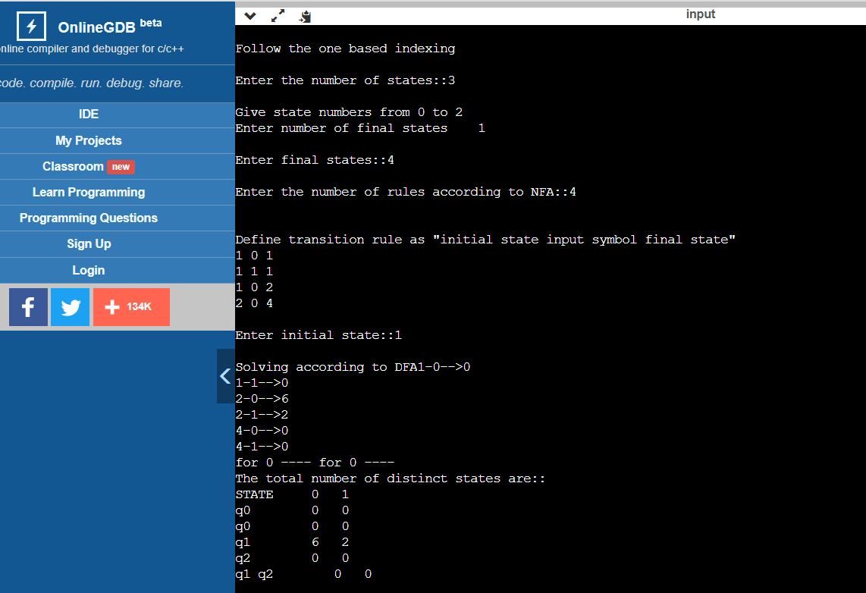

**Result:**

A C- program was written and implemented to convert a Non-Deterministic Finite Automata to a Deterministic Finite Automata.